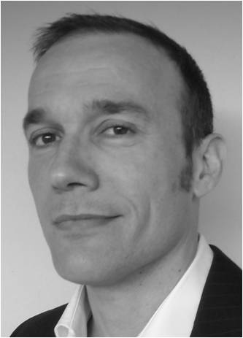

Christos Livas DDS, D. Orth, Dr med dent

Christos Livas graduated from the Faculty of Dentistry, Aristotle University – Military School of Officers Corps, Thessaloniki, Greece in 1998. Subsequently, he served as a consultant at the Department of Restorative Dentistry, 251 Hellenic Air Force VA General Hospital, Athens, Greece. In the years 2003-2007, he underwent specialty training in Orthodontics at the Radboud University Nijmegen Medical Centre. For the coming 5 years, he was assigned as Associate Director, Department of Orthodontics, 251 Hellenic Air Force VA General Hospital. During the same period, he was offered a Visiting Researcher position at the Department of Orthodontics and Dentofacial Orthopedics, University of Bern, Bern, Switzerland, where he obtained his doctoral degree (Dr med dent) in 2012. Since December 2012, he has joined the Department of Orthodontics, University of Groningen as full-time staff member. Christos Livas supervised and presented several research activities. He is currently reviewer of leading orthodontic journals. His study on bacteremic effect of mini-implants received the ‘Best poster award’ at the latest EOS congress. His main research interests are mini-implant anchorage and thermoplastic functional appliances.

